**Lesson 8: Past simple / Simple past**

**Simple Past Form**: Sub + V2 (past simple verb) + ….

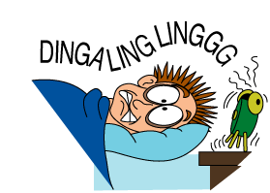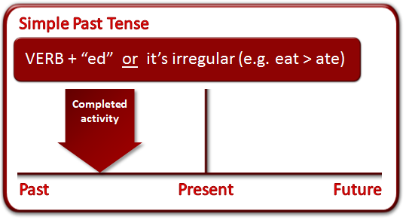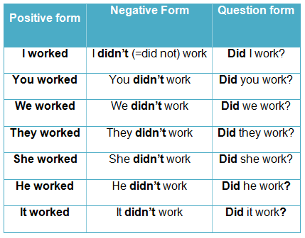

*“Dave got up every morning at 7 o’clock when he was a teenager.”*

**D:\PNC\COMPOSITIONS\Flèches\Arrow2.jpg**

Time expression: in 1990s, in 2015, yesterday, a year ago, last night…

**▪ For an action that started and ended in the past:**

🡺 For example: *I saw a ghost last Friday.*

**▪ For a repeated action in the past:**

🡺 For example: *When I was young, I watched lots of television every day after school*.

🡺*I always gave my mother flowers on her birthday.*

* **The spelling of the simple past form (-ed forms)**

|  |  |  |  |
| --- | --- | --- | --- |
| **Verb ending in a ….** | | | |
| **1. silent ‘*e’*** | **2. vowel + *y*** | **3. consonant + *y*** | **4. other forms** |
| close = close**d**  die = die**d**  phone = phone**d** | play = play**ed**  destroy = destroy**ed** | marry = marr**ied**  carry = carr**ied**  study = stud**ied** | visit = visit**ed**  miss = miss**ed** watch = watch**ed**  finish = finish**ed**  fix = fix**ed**  buzz = buzz**ed** |

**√ Special cases of the -ed forms:**

🡺 Follow these rules when there is a consonant after a vowel (stop, ban, open, offer...)

* If there is a consonant after a stressed vowel at the end of the word, double the consonant  
  stop – sto*pp***ed** ban – ba*nn***ed** swap - swa*pp***ed**
* If the vowel is not stressed, we do not double it:  
  open - open**ed** (Here the stress is on 'o', not the 'e'.)  
  offer - offer**ed** ( Here the stress is on 'o', not the 'e'.)

🡺 In British English we double the last *l* even though the last vowel is not stressed. Here are some examples:

* travel - trave*ll***ed**
* cancel - cance*ll***ed**
* level - leve*ll***ed**

**Practice**

**A. Instruction:** Put the regular verbs in the correct category.

|  |
| --- |
| cry like stop wait stay clap  enjoy label agree marry explain prefer  hop care bury use jog fail |

|  |  |  |  |
| --- | --- | --- | --- |
| **- d only** | **- ed only** | **- ied only** | **double consonant + -ed** |
| lived | cleaned | studied | shopped |
| Liked | Waited | Married | Stoped |
| Agreed | Stayed | Buried | Clapped |
| Cared | Enjoyed |  | Jogged |
|  | Explained |  | preferred |
|  | used |  | lebelled |
|  | failed |  | Hopped |

**B. Instruction:** Complete the story with the correct form of the verbs in brackets.

|  |
| --- |
| A young man aged 13 (1) .............................. (rob) the Simpson Bank in Motown yesterday night.  He (2) ........................... (use) his toy gun and (3) ............................. (travel) by his father's red BMW. He (4) ........................... (carry) the money in his sister's school bag. The young man  (5) ..................... (hurry) to his grandma's garden to hide the money there. When he  (6) .......................... (enter) the garden, he could see a policeman. The policeman (7) ..................... (start) to chase him. The young man (8) ....................... (drop) the bag with the money. - Suddenly, he could hear his telephone.  "Bob, are you still asleep?"  "Oh, mum. I had a terrible dream!" |

**C. Instruction:** Change the following verbs into past simple form.

|  |  |  |  |
| --- | --- | --- | --- |
| **Infinitives** | **Past simple** | **Infinitives** | **Past simple** |
| be (am / is / are) |  | feel |  |
| break |  | find |  |
| buy |  | lose |  |
| choose |  | pay |  |
| do |  | spend |  |
| eat |  | think |  |

**D. Instruction:** Complete the table in the simple past.

|  |  |  |
| --- | --- | --- |
| **Positive** | **Negative** | **Question** |
| He wrote a book. | _ _ _ _ _ _ _ _ _ _ _ _ _ _ _ _ _ | _ _ _ _ _ _ _ _ _ _ _ _ _ _ _ _ _ |
| _ _ _ _ _ _ _ _ _ _ _ _ _ _ _ _ _ | She did not win. | _ _ _ _ _ _ _ _ _ _ _ _ _ _ _ _ _ |
| _ _ _ _ _ _ _ _ _ _ _ _ _ _ _ _ _ | _ _ _ _ _ _ _ _ _ _ _ _ _ _ _ _ _ | Were they at school? |

**E. Instruction:** Complete the following sentences with the correct form of the verbs in brackets.

|  |  |  |  |
| --- | --- | --- | --- |
| 1 | I ___________ (loose) my watch in the park. | 6 | We had a garage where we ___________ (keep) our car. |
| 2 | David ___________ (not / hurt) his knee. | 7 | Ali ___________ (cut) his knee. |
| 3 | I kicked the ball, and it ___________ (break) a window. | 8 | The glass ___________ (fall) off the table. |
| 4 | My new shoes ___________ (not / cost) a lot of money. | 9 | We ___________ (sell) our old car. |
| 5 | I ___________ (get) this book from the library. | 10 | We ___________ (buy) a new car. |